URL: <http://student30712.bucomputing.uk/console>

**Stock Management Console for SOSA**

SOSA require a web-based stock management console. It must allow an admin to add to and delete from the database. Admins must be able to search for products on the database. They must also be able to update product information on the database.

**File Structure**

I intend the search feature to be on the homepage (index) to allow users to search through the database once as soon as they have accessed the console.

The search feature will rely on 3 external ‘php’ files.’ One ‘php’ file will be responsible for connecting our web-based system to the database, and another for finding items on the database via their unique item id code. The third file will be responsible for general searches, allowing users to search via item names/descriptions, sizes, genders, prices and stock amounts.

The add feature will rely on 2 external ‘php’ files. The first, again, responsible connecting the console to the database. The other script will be responsible for adding the user input to the database.

The console will also include a product list. It is here where the user will be given the option to update or delete products on the database. This product list will rely on 3 external ‘php’ files. One script will be the script responsible for connecting the database to the console. Another script responsible for the deletion of products and the final script for updating records in the database.

File Structure:

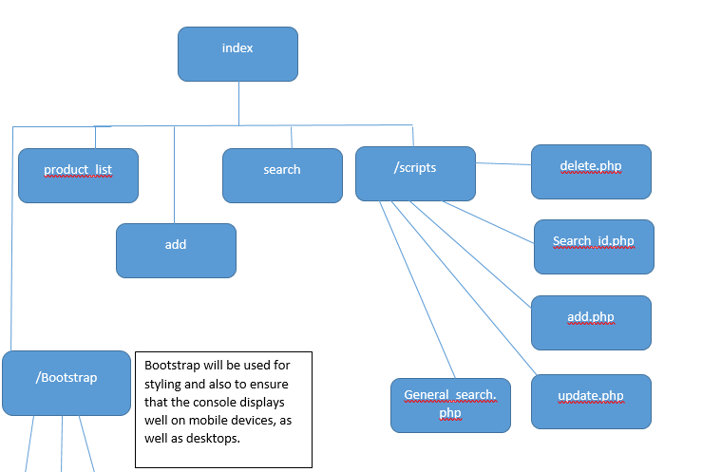

Db_con.php

**Database ERD**

tbl_item

item_id INT AUTO INCREMENT NOT NULL,

item_desc VARCHAR(140),

sex CHAR(1),

item_size VARCHAR(3),

item_price DECIMAL(6,2),

stock INT (4)

Item_ID will be used to uniquely identify each record found on our database, therefore it will be our primary key. It will auto increment, and null values will be constrained, to save the user having to think of a unique ID every time they add data to the table. Item_size will allow for 3 characters in case SOSA end up selling XXL and XXS small sizes in the future. Stock values can reach up to 9999, as it is an online store and we must consider that online stores may stock more than a standard retail store.

**Self-Reflection**

|  |  |  |  |
| --- | --- | --- | --- |
|  | **Yes (completed)** | **Partially completed** | **No (not submitted)** |
| **Report** |  | | |
| File structure with logical flow explanation | YES |  |  |
| Database design with rationale | YES |  |  |
| **System** |  | | |
| Search function | YES |  |  |
| Edit function | YES |  |  |
| Add function | YES |  |  |
| Delete function | YES |  |  |
| Use of front-end template | YES |  |  |
| Additional features |  | Item_IDs descend in order |  |

**In your own opinion, what is the best part of your work?**

I am most proud of having an ID search as well as a general search. This is because an ID search allows for users to search for details about very specific items.

**In your own opinion, what is the worst part of your work?**

I’m not particularly happy with the fact that I could not find a way to give the user a proper error message when failing to edit product details. Instead they are asked to re-direct to the product list page. I understand I could have at least styled this page. However, I was limited on time.

**In your own opinion, what is the part you struggled most with?**

Definitely the update/edit script!